PAKO MATTHEWS
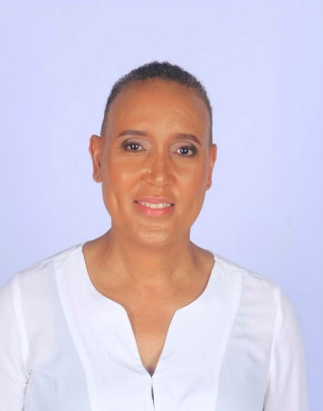
Executive Leadership Coach | Speaker | Facilitator
Helping leaders navigate change with courage, clarity and authenticity.

About Pako
Leadership has never been about having all the answers. It begins by asking better questions.
Pako Matthews is an Executive Leadership Coach, Facilitator and Speaker with more than three decades of experience spanning business strategy, leadership development, organisational transformation and executive coaching.
After building a successful corporate career in information systems, business strategy and partner management, Pako followed her passion for developing people and has spent the past decade coaching executives, senior leaders and leadership teams across the public and private sectors.
She is known for creating reflective, psychologically safe spaces where leaders are challenged to think differently, lead more intentionally and navigate complexity with greater confidence. Her style combines strategic insight, warmth, authenticity and practical wisdom, leaving audiences inspired as well as equipped with tools they can immediately apply.

Signature Keynote

The Phoenix Project
Reinventing Yourself Without Losing Yourself
Change is inevitable. Losing yourself in the process doesn't have to be.
In this deeply personal and thought-provoking keynote, Pako explores what it means to rebuild after disappointment, transition, loss, career change and personal adversity. Audiences leave with practical insights on resilience, identity and the courage to create a life and leadership journey that remains true to who they are.
Ideal for:
- Leadership Conferences
- Women's Leadership Events
- Executive Retreats
- Personal Leadership Development

Additional Speaking Topics

The Invisible Leader
The Hidden Behaviours That Quietly Shape Leadership
The greatest influence leaders have often comes from behaviours they do not realise they are demonstrating. This keynote explores the subtle habits that shape trust, culture and leadership effectiveness.

Leading Through Change
Leading Yourself Before You Lead Others
Helping leaders navigate uncertainty, complexity and organisational change while remaining grounded, emotionally intelligent and purpose-driven.

Emotionally Intelligent Leadership
The Conversations Great Leaders Don't Avoid
Exploring the role of emotional intelligence, courageous conversations and psychological safety in building high-performing teams.

The Leader Within
Sustainable Leadership Starts on the Inside
Leadership begins with self-awareness. This keynote explores how leaders build resilience, authenticity and sustainable performance without sacrificing their wellbeing.

Coaching & Facilitation Expertise
- Executive Coaching
- Leadership Development
- Executive Presence
- Emotional Intelligence
- Psychological Safety
- Women in Leadership
- Difficult Conversations
- Graduate Development
- Team Effectiveness
- Enneagram in Leadership
- Leadership Team Facilitation

Why Organisations Work With Pako
Organisations value Pako's ability to combine strategic thinking with genuine human connection.
Her sessions are known for creating meaningful conversations that challenge assumptions, deepen self-awareness and inspire practical action. Rather than providing quick fixes, she equips leaders with the mindset and tools to lead themselves and others with greater courage, authenticity and intention.
Participants frequently describe her style as engaging, insightful, relatable and thought-provoking.

Professional Background
- MBA, University of the Witwatersrand
- BCom Information Systems
- Executive Leadership Coach
- Facilitator
- Speaker

Closing Quote
“Leadership is not about having all the answers. It is about creating the conversations that help people discover better ones.”
— Pako Matthews

